Debugging the server in Eclipse

Install the pydev project (<http://pydev.org/>) either directly from their web site or using Eclipse’s Install New Software option from the Help menu.

From the debug icon, , select Debug Configurations.

Create a new configuration  that is a subtype of Python Run.

Set the following:

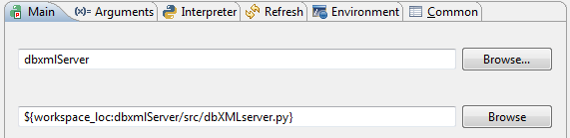

Command line arguments:

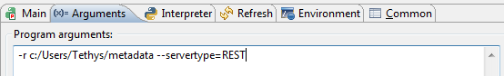

(values should be set appropriately; the above is an example)

After configuring, the debugger can be launched by pressing the Debug button. Recently launched configuration appear on the debug icon and can be launched without the configuration dialog.